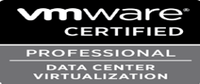
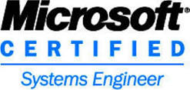
RAGHUNATH K C 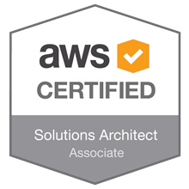 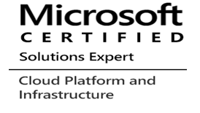
Email : raghunath.kc@gmail.com

Phone : +91 9845147955  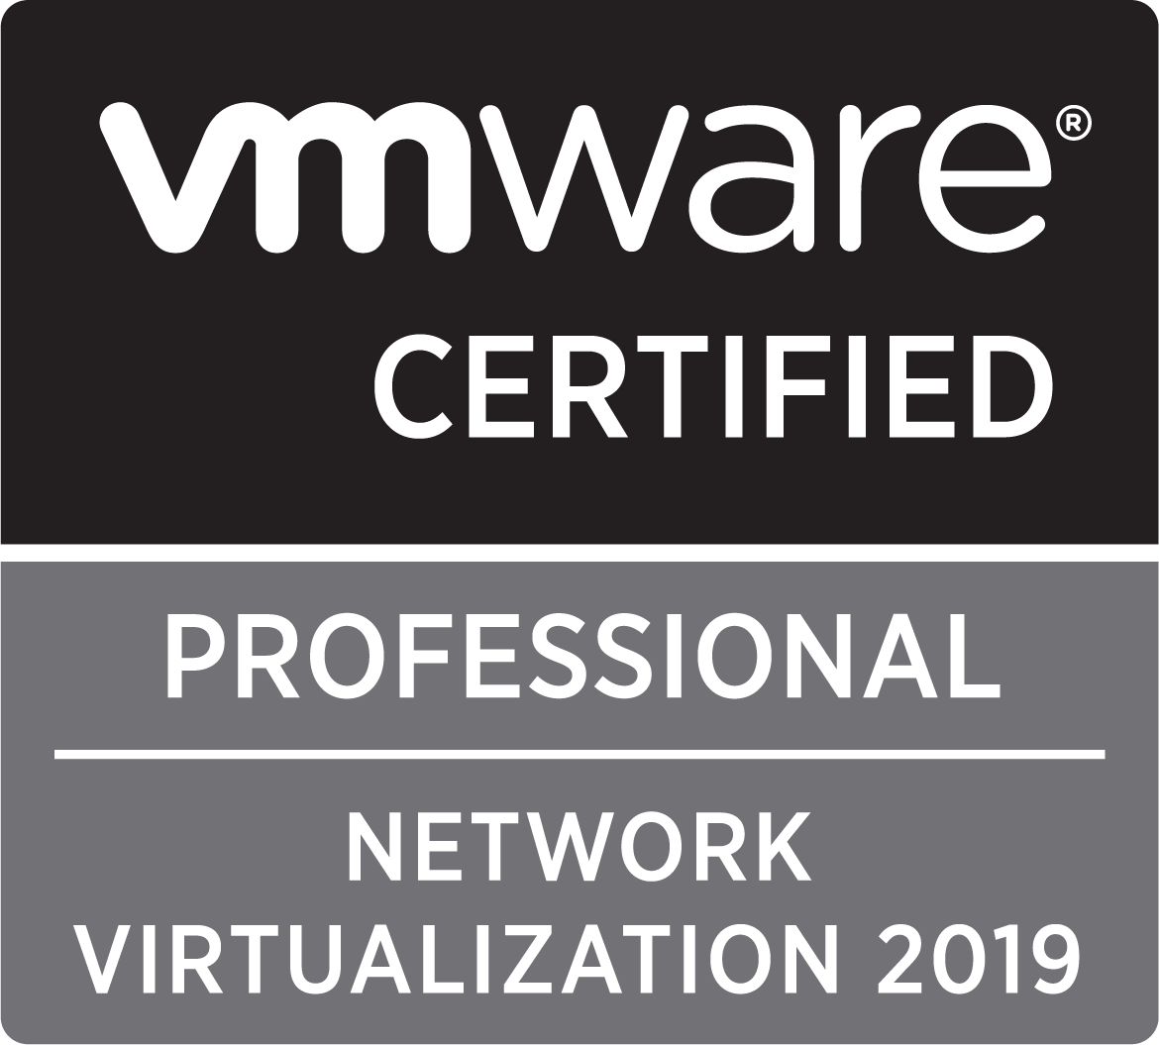

----------------------------------------------------------------------------------------------------------------------------------------------------------------------
Overview
Looking forward to a challenging and competitive work atmosphere leading to a professional experience with a dynamic and progressive organization where my skills, talents and abilities will be utilized to the fullest for mutual benefit.
Experience Summary
Professional with around 12 years of experience in successful design, implementation, integration of systems primarily in the domain of virtualization, cloud computing, Data Center operation and Migration.
Cloud Architecture and Design
- Public Cloud Migration (AWS/AZURE/GCP)
- Hybrid Cloud Architecture ,Design and Migration
- Data Center Consolidation and Migration
- Devops and automation |Git Github Gitlab Puppet Chef, Terraform, Ansible, Jenkins, Kubernetes, Docker PowerShell 2012 Python]
- Virtualization and cloud infrastructure design and implementation
- Project management and data center management for innovation, problem resolution and systems development
Core Strengths: Data Center transformation | Infrastructure assessment | TCO optimization | Disaster Recovery and Business continuity solution | Identity and Access management | Infrastructure and Cloud security
Technical Expertise
Virtualization: VMware ESXi 3.X/4.X/5.X/6.X, Microsoft Hyper-V 2008/2012/2016.
Operating Systems and Major Applications: Windows 2000/2003/2008/2012, Active Directory, DNS, DHCP, Microsoft Cluster. Reshat Linux
Hardware: Install, Configure, Management of IBM/HP/DELL/CISCO/Hitachi Rack servers and Blade servers, Configuring SAN storage of HP EVA 3000/6000, Dell EqualLogic, Hitachi Modular AMS 2000, Enterprise USP-V and USP-VM,
Migration and Consolidation Tools: Platespin Migrate, Protect, Recon, VMware Converter, Double take, Microsoft Rich copy. Dell VSM, Zerto, Sm9 ,Service Now, Quest ARS,
Cloud Technologies: VMware, Microsoft Azure, Amazon Web Service, Rackspace Google Cloud.
Major Training attended: Install Config Manage of VMware vSphere 4.x,5.x,6.x VMware Network Virtualization
Architecting Microsoft Azure Solutions
Professional Memberships / Certifications:
Certifications | Year of completion
VMware Certified Professional - Network Virtualization 2019 | (NSX v6.2)(2V0-642 VMW-01987674C-00590806
AWS Certified Solutions Architect - Associate certificate | July 2018 Q2MPL5R1JM11QYKQ
Architecting Microsoft Azure Solutions | November 2017
VMware Certified Professional-DCV(VCP6-DCA) | January 2017 VMW-01987674C-00590806
ITIL V3 foundation in IT service management | January 2017
VMware Certified Professional | September 2013
Microsoft Certified System Engineer(MCSE) | May-2008
Diploma in computer software (PGDCA) | 2007 to 2008
Diploma in computer hardware from | 2006 to 2007
Employment Summary
Duration | Organization | Role
March-2018 To present | Larsen & Toubro Infotech ltd  Bangalore | Technical Lead
March 2017 To December 2017 | Oracle India Litimited [Pay role off Blue Rose Technologies Pvt Ltd] | Technical Consultant
August 2015 To March 2017 | Hewlett-Packard Global soft Private limited[Pay role off KPIT Technologies Ltd] Bangalore | Technical Consultant
September 2014 To March2015 | Orbit Peripherals Pvt Ltd (Hp Partners) | Senior Associate
May 2007 – August 2014 | Acto Information Systems (India) Pvt Ltd | Systems Engineer
August 2006 - April 2007 | Orbit Peripherals Pvt Ltd | Support Engineer

Qualifications
Degree and Date | Institute | Major and Specialization
Bachelor Of Technology [ 2006] | Bundelkhand University | Computer Science Engineering

Assignments and Projects
Projects | Period | Position | Roles
Data Center Consolidation and AWS Cloud Support | March-2018 To present | Technical Lead | Data Center VMWARE AWS and Windows Azure Cloud Support
Data Center Consolidation and OPC loud Support (Oracle India Limited Project’s Calypso and Tesco) | March 2017 To December 2017 | Technical Consultant | Data Center VMWARE Windows OPC Cloud Support
Data centre Consolidation and Cloud adoption (Hewlett-Packard Global soft Private) | August 2015 To March 2017 | Technical Consultant | Data Center VMWARE Support Windows Micro soft Azure
Data centre Migration of Wintel Servers [Orbit Peripherals Pvt Ltd] | September 2014 To March2015 | Senior Associate | Remote Wintel Infrastructure Management and Data Centre Migration.
Remote Wintel Infrastructure Management and Data Centre of Wintel Servers [ Acto Information Systems] | May 2007 – August 2014 | Systems Engineer | Systems Engineer Vmware Wintel Server Administrator
Desktop/systems Engineer [Orbit Peripherals Pvt Ltd] | August 2006 - April 2007 | Support Engineer | Technical Supports Systems and Hardware
Job Responsibilities
- Ability to understand the design from the shared design document, and plan for the implementation / configuration
- Implement and Configure end to end all aspects of AWS includes but not limited to the list below as per design
  - New EC2 Instances, conversion from snapshot / AMI
  - S3, Glacier and EBS Storage, snapshots
  - Data retention policies
  - VPC , Subnet, ELB, Internet Gateway, Nat Gateway, Multi AZ deployment and replication
  - Security groups and ACL ( Access Control List)
  - Configuring snapshot based backup and restoration as needed
  - SNS, RDS, R53, Replication of Data within Availability Zones,
  - Configuring cloud watch monitoring and alerts
  - OS hardening
  - Deployment and configuration of RDS including Multi AZ deployment
- Configuration of Disaster Recovery using mix of tools as EBS to S3 to Glacier Automated Data Movement.
- Demonstrating “User Acceptance Tests” for all the Amazon AWS Components at Infrastructure layer including Compute, Storage, Backup, DR, Network, Security and Load Balancing.
- Scripting for automating the repeatable tasks (Provisioning, Monitoring, Backup, DR-Sync and image Creation).
- Implementation and Monitoring of Security Aspects of AWS (Key Pairs, Virtual LAN, Security Access)
- Generating Reports using AWS portal and tools.
- Interfacing with IT Infrastructure teams for day to day tasks related to connectivity, operations and Troubleshooting.
- Migration of data center based workload using Amazon export-import tool or any other methods
- Helping project team for analysis of the application and infrastructure assessment for cloud migration and cloud suitability
- Troubleshooting the AWS related issues within stipulated time frame
- Design Low Level Detailed Migration Plans for Workloads from Physical or Virtual Servers to AWS
- Migration of Physical and Virtual OS (Hyper-V, VMware and Azure) to AWS using various Tools as P-to-V and V-to-V.
- Demonstrating “User Acceptance Tests” for all the Amazon AWS Components at Infrastructure layer including Compute, Storage, Backup, DR, Network, Security and Load Balancing
- Designing and implementing Data Center solutions
- Installing and managing ESX/ESXi 4.X/5.X/6.X and VCenter servers.
- Configuring and managing VMware Clusters
- Configuring Hyper-V, SCCM, and Microsoft SQL Clusters.
- Configuring SAN, iSCSI based storage for ESXi host
- Configuring Network port groups, VLAN, and VM Kernel networks
- Working with VMotion, Storage VMotion, HA, and DRS, Fault Tolerance
- Configuring update manager and updating the hosts and guest machines
- Configuring Storage Management tools like VSM, Multipathing.
- Working with P2V, V2V conversions using VM Converter and Platespin.
- Windows server troubleshooting patching of server using WSUS Knowledge on McAfee/Antivirus Server builds and hardening concepts like Windows 2008, 2012 Knowledge of HP servers hardware and cisco UCS VMWare ESXi troubleshooting ESXi build and configuration Troubleshooting Vcenter issues like HA, DRS, Snapshots etc
- Managing and Troubleshooting Hyper-V
- Building 2003/2008 operating systems on Blade, Physical and VMware Virtual servers
- Decommission of Windows servers
- Configuring DNS, WINS and IP in Windows Client.
- Configuring Belkin and BT routers.
- Meeting metrics such as OLA, SLA as prescribed by the Organization.
- Worked on various technologies like VMWare, Citrix Xen Server, Microsoft Hyper-V
- Configuration, troubleshooting and administering on Active Directory, DNS, DHCP, VPN.
- Configuring IIS 5.0 and 7.0, creating websites and virtual directory.
- Experience on configuring and troubleshooting RAID on servers.
- Provide WSUS patching and upgrades for all servers on monthly schedule.
- Troubleshooting and directly interact with end users, receiving the mails from end users and raise the interaction tickets and analyzing as per the end user requirements.
- Managing Virtual Infrastructure and building servers in VMware environment.
- Creating and configuring Virtual machines and deploy Virtual machines from templates.
- Creating and managing resource pools and adding the VM’s into resource pools.
- Manage VM’s using VMware Virtual Center and Vsphere Client
- Creating and managing Datacenters and Clusters.
- Performing Snapshots, Cold migrations and hot migrations.
- Creating templates and deploy Virtual Machines.
- Moving VM’s from one LUN to another LUN using Storage VMotion.
- VMware cloning, expanding disks, adding datastore to ESX Servers.
- Physical to Virtual (P2V) and Virtual to Virtual (V2V) migration using VMware converter.
- Proficient in VMware technologies: VMotion, SVMotion, High Availability, DRS

System Administration/Support:
- Managing Active Directory, DNS and DHCP
- Creating and managing the Group policies
- Installing and configuring Windows 2012/2008/2003 Reshat Linux servers
- Installing configuring and managing Microsoft Cluster services
- Configuring the Blade servers, Blade SAN Switches and Network Switches
- Configuring Troubleshooting server hardware (HP, DELL, Fujitsu, SUN and IBM)

Linux System Administration/Support:
- Led technical site relocation project involving up to 40 servers successfully completing project in a single weekend.
- Diagnosed and resolved complex load balancing issue by phone for global site amazing and satisfying client.
- Converted Linux systems from local password authentication to LDAP and NFS homes significantly increasing administrative efficiency.
- Coordinated resources with varied programming expertise to create a holistic solution to system update and service interruption issues.
- Educated users on business interruption risk and received their buy in for system standardization and update.
- Created a process for system updates to minimize risk of application failures.

Personal Details
- Full Name : Raghunath K C
- Place of Birth : kurumakanahalli, Karnataka, India.
- Marital Status : Married
- Date of Birth : 26/05/1980
- Passport # : Z2744750
- PAN # : AJLPR8393R
- Aadhaar # : 2505-4388-2287

Declaration:

I do hereby Declare that all the above stated information is true to my belief.

Place:

Date: Signature

